**Practical 1(A)**

**Aim:** Create a program that asks the user to enter their name and their age. Print out a message addressed to them that tells them the year that they will turn 100 years old.

**Code:**

print("11_KhushiTiwari")

name = input("Enter your name: ")

age = int(input("Enter your age: "))

year = str((2017 - age)+100)

print(name + " will be 100 years old in the year " + year)

**Output:**

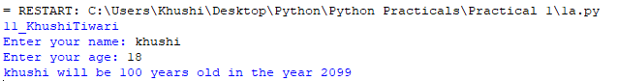

**Conclusion:** Successfully performed this practical.

**Practical 1(B)**

**Aim:** Enter the number from the user and depending on whether the number is even or odd, print out an appropriate message to the user.

**Code:**

print("11_KhushiTiwari")

number = int(input("Enter a number: "))

mod = number % 2

if mod > 0:

print("This is an odd number.")

else:

print("This is an even number.")

**Output:**

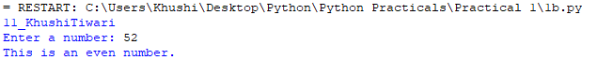

**Conclusion:** Successfully performed this practical.

**Practical 1(C)**

**Aim:** Write a program to generate the Fibonacci series.

**Code:**

print("11_KhushiTiwari")

n = int(input("Enter length of Fibonacci series: "))

num1 = 0

num2 = 1

next_number = 0

count = 1

while(count <= n):

print(next_number, end=" ")

count += 1

num1 = num2

num2 = next_number

next_number = num1 + num2

t_number = num1 + num2

**Output:**

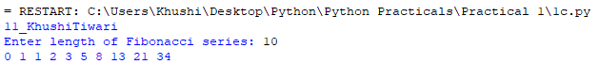

**Conclusion:** Successfully performed this practical.

**Practical 1(D)**

**Aim:** Write a function that reverses the user defined value.

**Code:**

print("11_KhshiTiwari")

txt = "apple"[::-1]

print(txt)

**Output:**



**Conclusion:** Successfully performed this practical.

**Practical 1(E)**

**Aim:** Write a function to check the input value is Armstrong and also write the function for Palindrome.

**Code:**

print("11_KhushiTiwari")

num = int(input("Enter a number: "))

sum = 0

temp = num

while temp > 0:

digit = temp % 10

sum += digit ** 3

temp //= 10

if num == sum:

print(num,"is an Armstrong number")

else:

print(num,"is not an Armstrong number")

# Write the function for palindrome

def isPalindrome(s):

return s == s[::-1]

# Driver code

s = (input('Enter a word: '))

ans = isPalindrome(s)

if ans:

print("Yes")

else:

print("No")

**Output:**

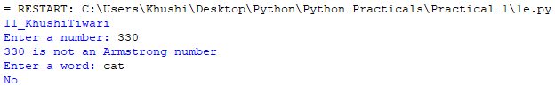

**Conclusion:** Successfully performed this practical.

**Practical 1(F)**

**Aim:** Write a recursive function to print the factorial for a given number.

**Code:**

print("11_KhushiTiwari")

def rec(n):

if n==1:

return n

else:

return n*rec(n-1)

num =int(input("Enter an integer: "))

if num<0:

print("Factorial does not exist for negative numbers")

elif num==0:

print("The factorial of 0 is 1")

else:

print("The factorial of",num,"is",rec(num))

**Output:**

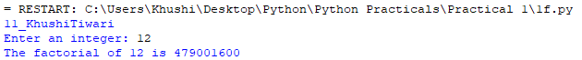

**Conclusion:** Successfully performed this practical.

**Practical 2()**

**Aim:** Write a function that takes a character (i.e. a string of length 1) and returns True if it is a vowel, False otherwise.

**Code:**

print("11_KhushiTiwari")

def check(c):

if(c=="a" or c=="A" or

c=="e" or c=="E" or

c=="i" or c=="I" or

c=="o" or c=="O" or

c=="u" or c=="U"):

return"True"

else:

return"False"

print("Enter the string to check: ")

c=input()

if check(c)=="True":

print("The character is Vowel")

else:

print("The character is not Vowel")

**Output:**

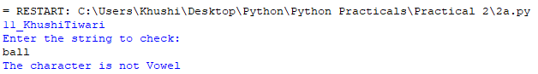

**Conclusion:** Successfully performed this practical.

**Practical 2(B)**

**Aim:** Define a function that computes the length of a given list or string.

**Code:**

print("11_KhushiTiwari")

str1 = input("Enter a string: ")

print("The length of the string is :", len(str1))

**Output:**

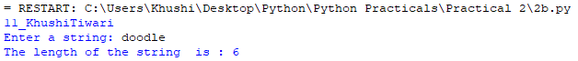

**Conclusion:** Successfully performed this practical.

**Practical 2(C)**

**Aim:** Define a procedure histogram() that takes a list of integers and prints a histogram to the screen.

For example, histogram([4, 9, 7]) should print the following:

****

*********

*******

**Code:**

print("11_KhushiTiwari")

def histogram(inputList):

for i in range(len(inputList)):

print(inputList[i]*'*')

List = [4,9,7]

histogram(List)

**Output:**

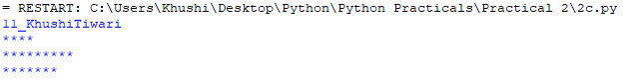

**Conclusion:** Successfully performed this practical.

**Practical 3(A)**

**Aim:** A pangram is a sentence that contains all the letters of the English alphabet at least once, for example: The quick brown fox jumps over the lazy dog. Your task here is to write a function to check a sentence to see if it is a pangram or not.

**Code:**

print("11_KhushTiwari")

import string, sys

def ispangram(str1,alphabet=string.ascii_lowercase):

alphaset = set(alphabet)

return alphaset <= set(str1.lower())

print(ispangram('The quick brown fox jumps over the lazy dog'))

**Output:**



**Conclusion:** Successfully performed this practical.

**Practical 3(B)**

**Aim:** Take a list, say for example this one:

a = [1, 1, 2, 3, 5, 8, 13, 21, 34, 55, 89]

and write a program that prints out all the elements of the list that are less than 5.

**Code:**

print("11_KhushTiwari")

a = [1, 1, 2, 3, 5, 8, 13, 21, 34, 55, 89]

number = int(input("Enter the number: "))

new_list = []

for i in a:

if i < number:

new_list.append(i)

print(new_list)

**Output:**

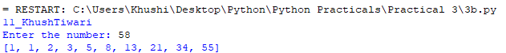

**Conclusion:** Successfully performed this practical.